SELECT
d.dept_name,e.emp_name, e.salary
FROM employee e
JOIN department d
ON d.dept_id= e.dept_id
WHERE e.salary> (
SELECT AVG(e2.salary)
FROM employee e2
WHERE e2.dept_id = e.dept_id
GROUP BY e2.dept_id
HAVING COUNT(*) >= 3
);

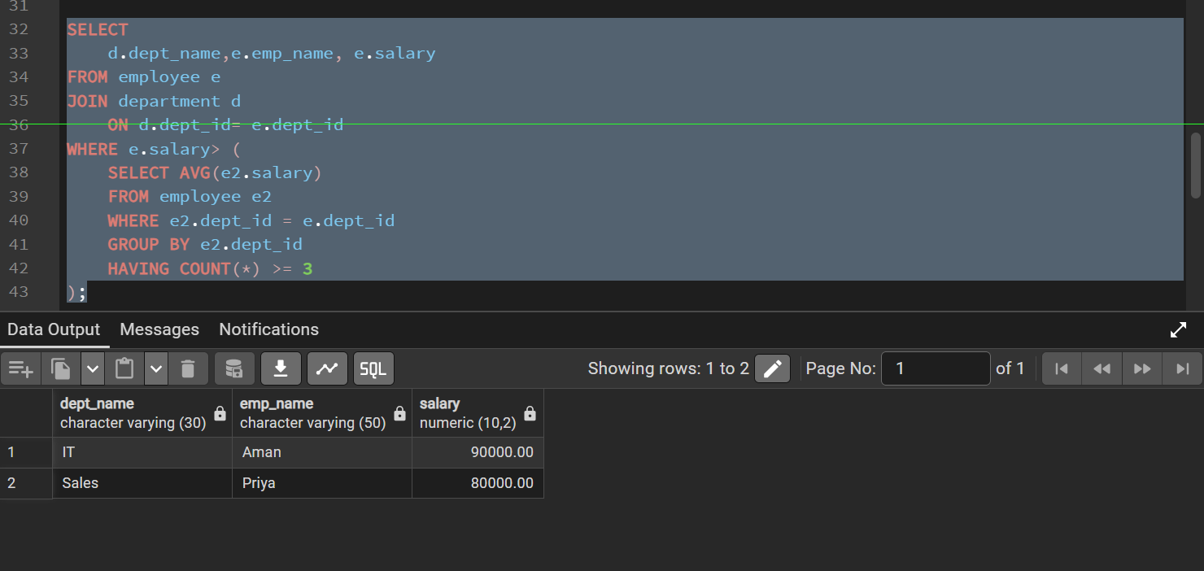

CREATE TABLE bank_customer (
customer_id INT PRIMARY KEY,
customer_name VARCHAR(50),
balance NUMERIC(10,2)
);

CREATE TABLE customer_audit (
audit_id SERIAL PRIMARY KEY,
customer_id INT,
customer_name VARCHAR(50),
action VARCHAR(20),
action_time TIMESTAMP
);

CREATE OR REPLACE FUNCTION log_customer_changes()
RETURNS TRIGGER AS $$
BEGIN
IF (TG_OP = 'INSERT') THEN
INSERT INTO customer_audit (customer_id, customer_name, action, action_time)
VALUES (NEW.customer_id, NEW.customer_name, 'ADDED', CURRENT_TIMESTAMP);
RETURN NEW;

ELSIF (TG_OP = 'DELETE') THEN
INSERT INTO customer_audit (customer_id, customer_name, action, action_time)
VALUES (OLD.customer_id, OLD.customer_name, 'REMOVED', CURRENT_TIMESTAMP);
RETURN OLD;
END IF;

RETURN NULL;
END;
$$ LANGUAGE plpgsql;

CREATE TRIGGER trg_customer_audit
AFTER INSERT OR DELETE ON bank_customer
FOR EACH ROW
EXECUTE FUNCTION log_customer_changes();

INSERT INTO bank_customer VALUES (1, 'jay', 60000), (2, 'papa', 849282);
INSERT INTO bank_customer VALUES (3, 'mummy', 80000);
DELETE FROM bank_customer WHERE customer_id = 1;
SELECT * FROM customer_audit;
